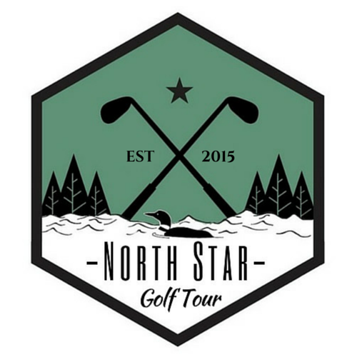
The 2015 North Star Tour
Sponsorship Options

All sponsorships are included on our website as well as pictures published in social media and local news papers
Tour Title Sponsorship: $50,000
Your company name will be added to the title of our tour (i.e. The _______ North Star Professional Golf Tour). Your company name and/or logo will be added into the logo for the tournament and will exist on all signs, banners, flags and trophies. Whenever broadcasted in any way, we will advertise the sponsorship and thanks to the contribution. Conditions for a sponsorship of this level are negotiable.
Tour Presenting Sponsorship: $25,000
Your company will be the presenting sponsor of our professional golf tournament (i.e. The North Star Open presented by _______). The name of your company will be added after the title of our tournament. Conditions for a sponsorship of this level are negotiable.
Presenting Prize Sponsorship: $5,000 - $15,000
Your company will be the highlight of our professional prize purse. Your company name and logo will be added in bold to an additional large sized check that will be presented with the 1st place prize to the winner during the awards ceremony.
Hole in One Sponsorship: $1000 or Prize
You get to choose which of the (4) par three’s you want to showcase your name or company. A sign will have your logo and prize shown on the tee box for this memorable contest experience. In the event that a hole in one is made by a professional on your contest par 3. Your sponsorship will go to the player.
Hole Sponsorship: $300
Your name or company will be showcased on the tee box of one of our (18) championship holes throughout the tournament.
Flag Sponsorship: $1000
This featured sponsorship covers the cost of custom flags for the 2016 season. Your name or company will be represented on every flag on the course as well as any flags presented as awards. (Includes extra website exposure through action shots and awards ceremony photos)

Charity
The North Star Professional Golf Tour is committed to community involvement and will make a substantial donation to Toys for Tots which is co-sponsored by Dellwood CC and the US Marines.

